
Packt Author Guidelines
Before you start writing, please read the following guidelines, and when you begin, ensure that you follow them! The guidelines are designed to make writing, reviewing and editing easier, and ultimately to help produce the high quality content that we all aspire to.
Please note that while these guidelines refer to books, they equally apply if you are writing only part of a book, a single chapter, or even a standalone case study.

Outline
The first piece of writing that you, the author, should produce is a detailed outline for each chapter you are writing. It is essential that you agree a detailed outline with your Acquisition Editor before you start writing. A detailed outline will ensure that you and the Acquisition Editor have the same understanding of what the book will cover, its level, length, and various other details. A good outline reflects the vision of the book. Please make sure that you write to the agreed outline. A good outline shows all sections and subsections with an explanatory text for each.
Outlines are not set in stone. You may find that the outline needs to be changed after the writing has started. These changes will need to be agreed between you and the commissioning editor.
In a multi-author book, the Acquisition Editor will ensure that all authors have the most up-to-date outline of the whole book. This is essential for ensuring the consistency of the material delivered by the various authors.
You will find a document with some tips for creating your outline in the Author Bundle.

Deadline
Before signing your contract, be certain that you can meet the agreed deadline specified for your contribution. Meeting the deadline of a book is essential for its success in the market.
Should you feel that events are conspiring to prevent you from completing your work on time, please contact your Acquisition Editor at the earliest possible opportunity to discuss the situation.

Page Count
In addition to the outline, you will need to agree on an estimate of the page count with your Acquisition Editor. Once writing is underway, and you find that your work may be substantially shorter or longer than expected, please discuss this with the Acquisition Editor; do not wait until you have finished writing.

Manuscript Format
Please use either Microsoft Word or Open Office Writer for creating your documents. The latter is freely downloadable from http://www.openoffice.org, and runs on Linux or Windows.
Please note that manuscript submissions will only be accepted if they are in either Microsoft Word .DOC or Open Office .SXW or .ODT format.

Styles and the Template
We will provide you with a word processor template before you start writing. By using the styles in the template, your document will be properly formatted, which is very important for the document’s progress through our editorial process.
Note that if you use any fonts or formatting outside of the template styles, this will be lost when we reapply the template in later parts of the editorial cycle, and accordingly, all the “unsanctioned” formatting will be lost.
When writing for Packt, please do not use any styles other than of those of the supplied template. If the template does not contain styles that you want to use, please discuss this with your Acquisition Editor.

Chapter Structure and Summary
Each chapter you write should have these elements:
- The chapter number and title at the start of the chapter
- An overview of what the chapter will cover, and what the reader can expect to learn
- The chapter must end with a summary of the chapter - this is the final section of the chapter with the heading "Summary"

Text
Each author has his/her own style in writing. However, there are some general rules that authors will need to adhere to:
- Use American English.
- Write at the level of your target audience. Do not omit information that readers may not necessarily know and would need to know to understand the topic you are writing about. At the same time, do not cover topics that the target readers should know before reading the book.
- Try to include the reader with the use of “we” and “us” instead of the exclusive “I” and “me”, unless the context necessitates otherwise. Do not change randomly from first person singular to first person plural or vise versa.
- Try to think on behalf of your reader and make sure that you progress in a clear, gradual, and consistent way.
- Be concise and to the point. Verbosity and repetition make the text difficult and boring to read.
- Do not use language that may be seen as offensive, discriminatory, racist, blasphemous, libelous, or defamatory.
- Avoid sexist language, and use gender neutral terms. For instance, use “salesperson” instead of “salesman”.
- Do not use foreign words or terms that the reader may be unfamiliar with.
- Spell-check and proofread your manuscript before submitting it.
- Avoid overusing forward references, such as “as we’ll see in a moment” or “which will be discussed in the next chapter”. It is indicative of poor structure of the book.
- Number the pages of the manuscript consecutively. No special numbering convention is needed as this will be set at the production stage.
- When using headings, they should always be followed by text, not another heading or subheading, even if this text is only an introductory sentence.
- Although you will not submit a camera ready copy, read a hard copy of the manuscript before submitting it. This will help you better assess the finished manuscript, as well as catch errors that you would miss when reading the manuscript on the screen.

Plagiarism
Plagiarism is never acceptable. Plagiarism is defined as "taking someone's words or ideas as if they were your own". If you find yourself wanting to quote material from another source (such as online reference material) in your chapters, and you are unsure of the best way to progress, contact your Acquisition Editor to discuss this. If you believe that freely available reference material does a better job than you could do yourself, then you should also contact your Acquisition Editor to confront this.

Images
You will undoubtedly want to make use of images in your document. There are two types of images that we will use – screenshots and diagrams – and each type requires a different treatment.

Screenshots
For taking screenshots, there are many utilities, such as Paint Shop Pro, Techsmith's SnagIt, and the GIMP, that offer great flexibility. You should try and ensure that you do not capture more of the screen than is necessary for the image. On Windows, Ctrl-Alt-Print Screen will capture an image of the window currently in focus, and this image may be pasted into a graphics program and saved.
To make the most of our printing process, screenshots should be in 256 colors and taken at a reasonably high-resolution. If you are taking screenshots on Microsoft Windows then we have a theme (file Packt.theme) that will set up the best combination of colors automatically. The screenshot files should be submitted in PNG or BMP format, at the same time as you submit the draft of your manuscript. You do not have to perform any further processing on your images, other than cropping to ensure that only the relevant area is shown.
Please resize windows used in screenshots to the minimum size possible to convey the necessary information -– don’t leave too much "empty" area in your screenshots.
For instance, if you look at the screenshot below you can see the empty space (circled):

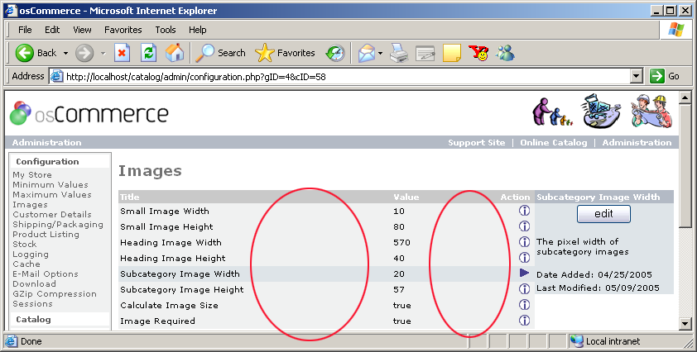

A better way to take this screenshot is to resize the window to fit the same information into a smaller area, without decreasing the readability of the image, or losing any of the information.
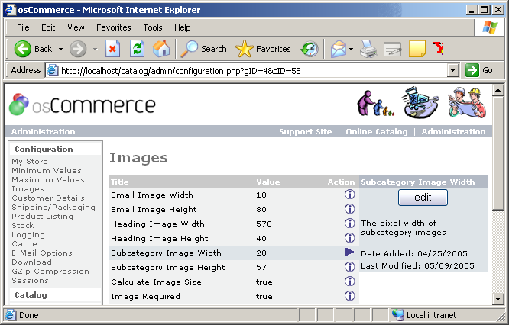

Of course, this does not mean making the screenshots very small, but the maximum width we can print effectively is about 800 pixels. A width of 640 pixels will look even better. The height is not such a problem. It's perfectly acceptable to have "tall" windows. Please also make sure that text is of a readable size. One thing that you can do is to increase the size of the font in the browser itself (Ctrl + Mouse Wheel on Windows will do this for example).
We have a wallpaper file (Packt_Wallpaper.jpg) that will help you resize windows to 800 x 600 and 640 x 480. If you use it, please make sure that the wallpaper is displayed at its original size and not stretched to fill your screen.

Diagrams
Diagrams are images that are not screenshots; they could show process flows or system architectures, for example. Diagrams will be redrawn by our own production team, but you need to provide the basic image from which they will work. This basic image can be a simple bitmap, or a scan of a hand-drawn diagram! Since the diagrams will be redrawn, you do not have to spend time agonizing over the fonts or the precise positioning, simply the general layout and the accuracy of the information contained. Please do not use the built-in diagramming capabilities of the word processor (such as Word Art in Microsoft Word for example) – we would much rather have a bitmap, ideally in PNG format.

Image Embedding and Submission
You should embed the images in the manuscript, but also ensure that you send the image files along with the manuscript. You will need to insert the filename of each image under the image in the manuscript (see the example document for an example of this). Use the following convention for your image files:
ISBN_CH_NO.png
where ISBN represents the last four digits of the ISBN of the book, CH is the two-digit chapter number, and NO denotes the two-digit image number. For example, 3426_04_09.png is the PNG file of image number 9 in Chapter 4 of the book whose ISBN ends with 3426. Your Acquisition Editor should have provided you with the ISBN when writing started – you will also find the ISBN in your contract.
Note that screenshots and diagrams both follow this same naming and numbering convention.

Code
Any code that you create for the chapter should be included as a separate submission. This code should contain a README file indicating the structure of the included code, and how the code should be installed and/or configured ready for use.

File Naming Conventions
When you first submit a chapter, please name the file ISBN_ChapterNo_1stDraft. For instance, when you submit the first draft of the first chapter of the book with ISBN 1035, name the file 1035_01_1stDraft.doc. Each time you submit a new version of the same chapter, please follow the same convention, this time increasing the number of the draft, so the second submission would be 1035_01_2ndDraft.doc, and so on.
From time to time, you may wish to submit a "work in progress" to your Acquisition Editor, so that they can give you some help on how to proceed toward the finished draft. In this case, please append _WIP to the filename, so that a work in progress of the first draft for the above book would be marked as 1035_01_1stDraft_WIP.doc.

July 31, 2008, version 10.

